Page: Omposter (XXX)
XXX consists of 4 dialogues. The navigation diagram is shown below.

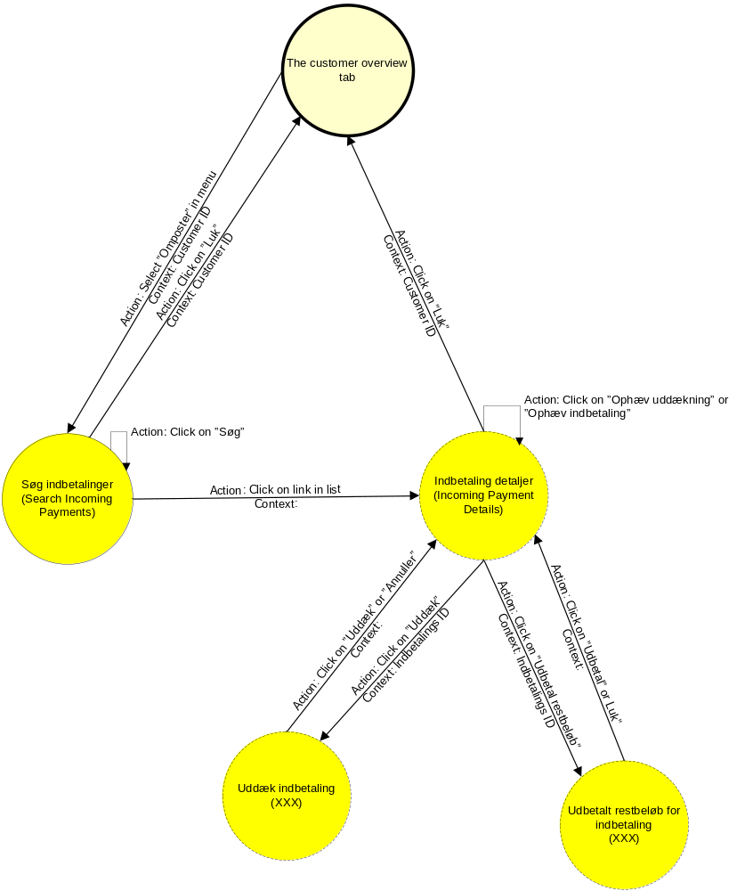
Figure 1 The XXX dialogue navigation flow

Søg indbetaling (Search Incoming Payments)
Search Incoming Payments can only be entered when the user has selected a customer, i.e. when the user has opened the Konto overblik (English: Customer overview) tab in [EFI-Sagsbeh-ODSB].
Below is a description of the different action widgets:
- “Søg” (English: Search): This button calls a service (DMIIndbetalingList) that lists the incoming payments according to the search criteria in top of the dialogue.
- Link in the list of incoming payments: This links opens the dialogue Incoming Payment Details (Danish: Indbetaling detaljer).
- “Luk” (English: Close): This button closes the dialogue and control is returned to the entry point of this dialogue.
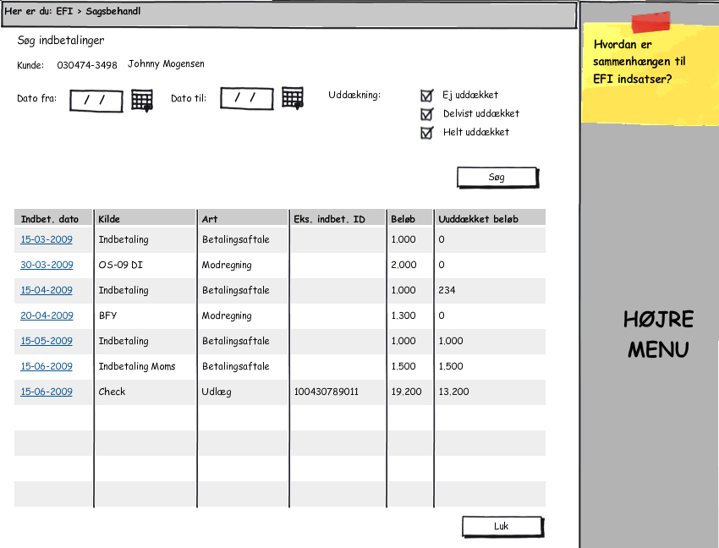
Figure 2 Søg indbetaling (English: Search Incoming payments)

Indbetaling detaljer (Incoming Payment Details)
Incoming Payments Details displays the details of an Incoming Payment including how the payment has been used to cover debts.
Below is a description of the different action widgets:
- “Uddæk” (English: XXX): This button opens the window “Uddæk indbetaling”. This button is only active if the incoming payment doesn’t cover any debts. If there are covered debts the button “Ophæv uddækning” has to be pressed first.
- “Ophæv uddækning” (English: XXX): This button calls a service (DMIKontoIndbetalingFordelingÆndr) that removed the current coverage of the incoming payment. This button is only active when the list “Nuværende uddækning” is not empty.
- “Udbetal restbeløb” (English: XXX): This button opens the window “Udbetal restbeløb for indbetaling”. This button is only active when there is an uncovered amount.
- “Ophæv indbetaling” (English: XXX): This button calls a service (DMIKontoIndbetalingFordelingÆndr) that withdraws the entire incoming payment.
- “Luk” (English: Close): This button closes the dialogue and control is returned to the entry point of this dialogue.

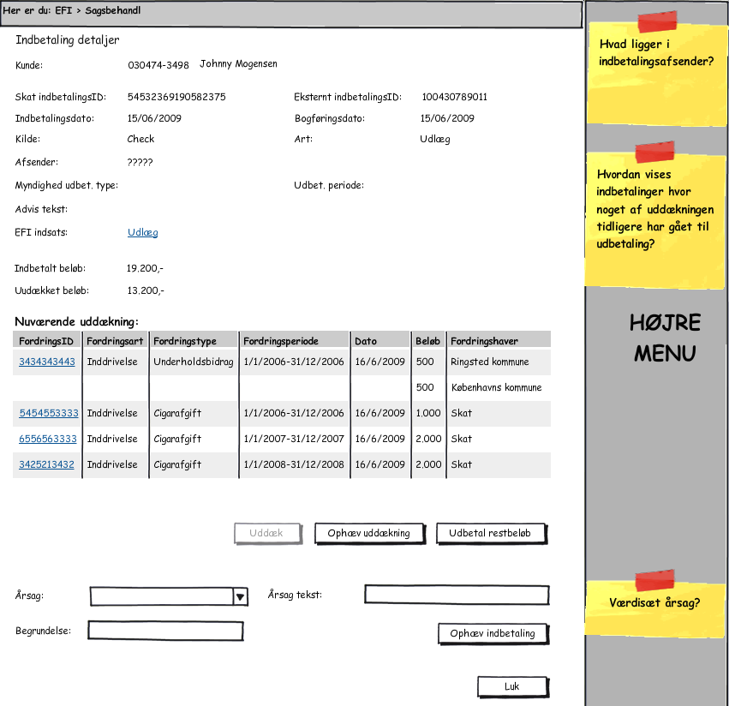
Figure 3 Indbetaling detaljer (English: xxx)

Uddæk indbetaling
“Uddæk indbetaling” displays an calculated coverage by calling the service DMIKontoIndbetalingFordelingBeregn when the window is initially opened. This coverage can be changed by the user.
Below is a description of the different action widgets:
- Up arrow and down arrow: These buttons allows the user to change the order in which the debts are covered.
- Radio-button group (English: XXX): When the window is opened only the debts covered in the calculation by DMI is shown. This radio button group allows the user to display all debts that the customer is liable for.
- “Hent” (English: XXX): This button calls a service that gets the details of the specified debt Id. This button allows the user to cover debts that the customer is not liable for.
- “Uddæk” (English: XXX): This button calls a service (DMIKontoIndbetalingFordelingÆndr) that updates the coverage of the incoming payment.
- “Annuller” (English: Cancel): This button closes the dialogue and control is returned to the entry point of this dialogue.

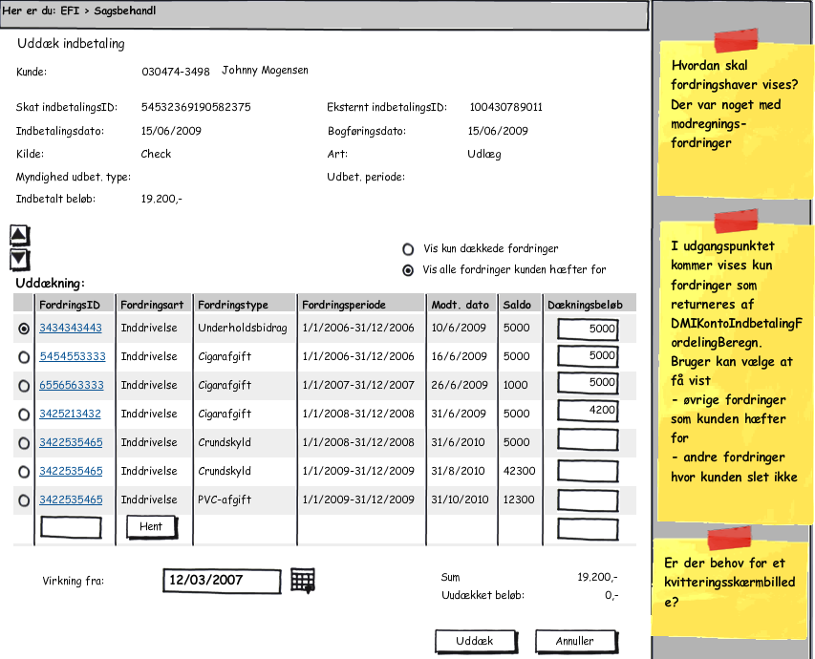
Figure 4 Uddæk indbetaling (English: xxx)

Udbetal restbeløb for indbetaling
“Udbetal restbeløb for indbetaling” allows the user to pay the uncovered amount to the customer.
Below is a description of the different action widgets:
- “Udbetat” (English: XXX): This button calls a service (DMIKontoUdbetalingOpret???) to transfer the uncovered amount to the customer.
- “Annuller” (English: Cancel): This button closes the dialogue and control is returned to the entry point of this dialogue.

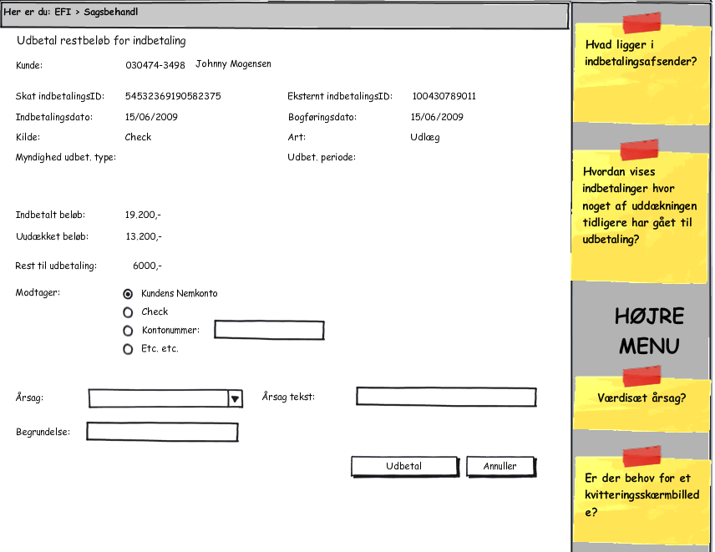
Figure 5 Udbetal restbeløb for indbetaling (English: xxx)
DIVERSE ÅBNE PUNKTER
ANT-MF-ODSB4-01 | ÆA 67 ikke placerbare indbetalinger: Er ikke udarbejdet endnu. Omposteringskravafklaringsforløbet afklarer om der er tale om en ÆA.
ANT-MF-ODSB4-02 | ÆA ?? - Dialoger til kasse-funktion, f.eks. til at håndtere indbetalinger  I dag er der en egen rolle (afdeling) som håndterer indbetaling. Sådan bliver det nok også i fremtiden.
ANT-MF-OSDB4-03 | Reaktion i EFI på dækningsløse betalingsmidler  Hej Per  I afklaringen af omposteringsskærmbillederne i EFI er der dukket et emne op, som vi bør behandle på DMI-taskforcen. Hvad skal der ske i EFI når kunden har betalt sin gæld med et dækningsløst betalingsmiddel, og SKAT efterfølgende tilbagefører betalingen?  Eksempelvis har kunden betalt alt med en check og al inddrivelse i EFI er afsluttet. Efterfølgende tilbageføres indbetalingen da checken er uden dækning, og hvordan får vi i denne situation sat inddrivelsen korrekt i gang igen i hhv. DMI og EFI.  Mvh.  Mette
Table 1 Assumptions for DMI Dialogues (ODSB 4)

Business perspective
This chapter describes possibilities for extending or enhancing the system, discovered during the work on the ODSB, but not covered by the contract.

Closer integration with the Resource component
The following functions integrate with the task list in the Resource component.
- Godkend transport/udlæg og indsætte beløb på transport (English: Approve transfer and insert amount)
- Identificer kunde (English: Identify Customer)
- Godkend afskrivning (English: Approve Write Off).
These functions are initiated from the task list. The task contains a link that brings the caseworker directly from the task list to the correct Receive Debts function.
When the case worker has finished the task in the Receive Debts dialogues, he/she has to manually mark the corresponding task in the task list as completed. This could be done automatically if the Receive Debts dialogues called the Resource component and notified about the completion of the task.

